Renju lesson on December 20, 2001
Hello everyone! Welcome to Online Renju Class. Today we will learn i10 opening. It was chosen by you. The three moves you see on the board make the i10 opening. About the evaluation, is it good for black or white? Ok, lets have one small test.
All of you have to evaluate i10 opening in the scale 0-100, where 0 is white sure win and 100 is black sure win. Please tell your evaluation and we will see whose evaluation is closest to mine.
According to my evaluation, i10 could be evaluated as 90.
Well, how many of you remember my 4th game against Nakamura? It was the d11 opening, changed to i10 after the 4th move. That game ended with draw. In rough calculation, draw should mean 50 in 0-100 scale, right? But it doesn’t mean i10 equals to 50. You ask my formula of evaluation. There are two methods. One, the easy one, is a statistical method. For example, check 10 high level games and see that black gets 9 points out of 10 games. That reminds me an interesting argument several years ago. Let me tell you. In 1997 I wrote an article about the future of renju. It was published in Renju World magazine. I was the chief editor of that magazine at that time. I published the article, telling the situation of present opening rule. In that article, I made some evaluations of openings. Among several openings, I evaluated i12 to be 90% black win (or was it 95). And, that article was critisized by Russian player Alexander Mihailov. Mihailov is the fan of i12 opening, and he felt offended that I gave so low evaluation to his favourite opening. He wrote a long article to show his disagreement. He told that my evaluation is totally wrong. And, he said he is ready to challenge me in 10 games of i12, either real or email. It was 4 years ago. I was quite upset about his article at that time. But as a chief editor, I published his article. He eagerly waited me to pick his challenge. But I did not accept his challenge. Why?
Because, I do nto need to prove I am right. I cannot prove everything to everyone in the world. Too many people. If I make these 10 games then I need to prove others too. The way I prove is in tournaments. If Mihailov reaches to WC, and plays i12 against me, he can have his first challenge game. So, you see, evaluations can easily cause critisizm. Therefore, let me add that the evaluations that I give are “my evaluations” and that is not necessarily the absolute truth. It is everyone’s free choice to believe my evaluations or not. I think, if I played i12 with him now, I would win with 10:0. It is not that I am better. It is the opening that is too good. I think, if Nakamura were black against me in i12 opening, he would beat me with 10:0 too.
Well, note that the evaluation has no direct relation with skill. Beginner can mess up i7 opening too. Right? Going back to the evaluations, the second formula of evaluations is based on my own analyses. It may be against all statistics. For example, i2 opening is maybe 80 according to statistics, but in my analysis, it is 100. So, whenever you see my evaluations, it is based on second time of evaluations. I10 has 90. It may be too high, but it is so based on my analyses. Some of you wonder, why all this is so important. Let me tell you why. Without having the right evaluation of openings and concept, the study of openings is just a waste of time. Having right evaluations helps you to make good choices. Do you have any idea how many important WC games I have lost because of bad choice of opening variant. Bad choices cost me the WC titles in 1995 and 1997. If I had made proper evaluations before games, I would save lots of trouble. Since 1999, I have carefully planned the opening and the evaluation of each variant. I hope, if you learn how to evaluate, or at least use some reliable evaluations, then your games results will go up fast. Until you learn to evaluate, you can use my evaluations. I hope it is helpful. And, remember, evaluations are not eternal, they change through the time as the theory develops. D11 opening evaluations have jumped up and down. D11 opening evaluations, 1990 – 50, 1995 - 30, 1997 – 85, 1998 – 80, 1999 – 85. 2000 – 60, 2001 – 75, 2002 - ?
Who can forecast the 2002 evaluation? My guess is, there will be struggle between black and white, and the evaluations will jump between 60-85.
When a “new white move” is found, it will take the evaluation down for weeks or months and then goes lowly up again as people dig through it.
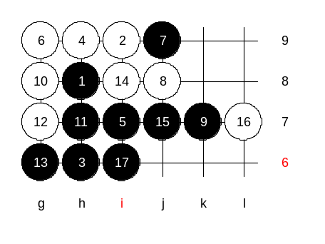
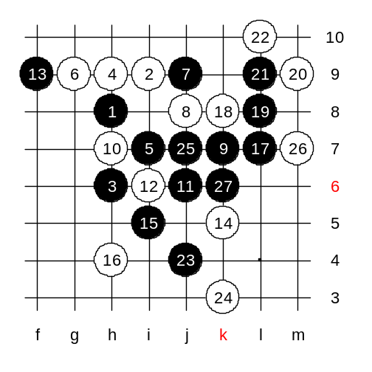
Thank you for listening, now we go to the second part of lesson that is particularly about i10 opening. There are several 4th moves to check. The most popular 4th move is h9. Do you want to check it first? Now, which 5th moves are possible here? Good, g9, i7, j9. Can you evaluate them too? G9 = 100, I agree. I7 = 90, I agree. How about j9? It used to be very strong. Maybe it’s 70 now. 70 means, black has a good advantage, can control the game and take the draw later if needed. But it is too weak to get any easy wins. Which 5th move shall we learn first? Ok, we will take i7 first. Move 6-g9 is quite weak. But lets check it anyway. We try 10-g8. How to win? Can white have a counter-attack after black’s h7? No, so black wins.

We try another 10th move. We try 10-h7. How to play? Easy win.

